# Pandas Agent Using Langchain

# Table of Contents

1. Acknowledgement

2. Introduction

3. Objectives

4. System Design

5. Implementation

6. Challenges

7. Lessons Learned

8. Applications

9. Conclusion

**Acknowledgement**

We would like to express our deepest gratitude to everyone who has contributed to the successful completion of this project. We would like to thank our **upgrade** team members for their dedicated efforts and collaboration. Special thanks to our mentors for their invaluable guidance and support throughout the development process. We also extend our appreciation to the open-source community for providing resources and libraries that made this project possible.

**Introduction**

The pandas_agent.ipynb file is an innovative extension of the Pandas library, designed to simplify and enhance data manipulation and analysis tasks. Pandas is a widely-used library in the data science community, known for its powerful and flexible data structures. However, as datasets grow in size and complexity, the need for more advanced and automated data handling tools becomes apparent. The pandas agent aims to address these needs by introducing an intelligent agent that can perform complex data manipulations, streamline workflows, and improve overall efficiency.

**Objectives**

The primary objectives of the **pandas_agent** project is to:

1. Extend the capabilities of Pandas DataFrames by adding advanced data manipulation and analysis features.
2. Simplify complex data operations, making them more accessible to users with varying levels of expertise.
3. Improve the efficiency and effectiveness of data analysis by automating repetitive tasks and optimizing performance.
4. Provide a robust and flexible tool that can be easily integrated into existing data science workflows.

**System Design**

The system design of the pandas_agent involves several key components:

1. **Data Ingestion and Preprocessing**: This module handles the import and initial processing of datasets, ensuring they are in the correct format for analysis.
2. **Core Functionality Enhancements**: The agent introduces new methods for data manipulation, such as advanced filtering, grouping, and aggregation techniques.
3. **Integration with Pandas**: The agent seamlessly integrates with existing Pandas DataFrame operations, allowing users to switch between standard Pandas functions and enhanced agent features effortlessly.
4. **Output Generation and Visualization**: The system includes tools for generating comprehensive reports and visualizations, providing insights into the data and the results of analyses.

**Implementation**

The pandas_agent is implemented in Python, leveraging the robust features of the Pandas library. The implementation process includes:

1. **Designing the Agent Class**: The core component of the pandas_agent is an agent class that extends the functionality of Pandas DataFrames. This class includes methods for advanced data manipulation and analysis.
2. **Adding Methods for Data Manipulation and Analysis**: New methods are added to the agent class to perform tasks such as filtering, grouping, aggregation, and data transformation.
3. **Integration with Pandas DataFrame Operations**: The agent class is designed to work seamlessly with existing Pandas DataFrame operations, allowing users to perform standard and enhanced operations interchangeably.
4. **Testing and Validation**: Extensive testing is conducted to ensure the agent functions correctly and efficiently with various datasets and use cases.

**Challenges**

During the development of the pandas_agent, several challenges were encountered:

1. **Compatibility with Pandas Versions**: Ensuring compatibility with different versions of the Pandas library required careful planning and extensive testing.
2. **Performance Optimization**: Optimizing the performance of the agent, particularly for large datasets, was a significant challenge. Techniques such as vectorization and parallel processing were employed to enhance performance.
3. **Handling Edge Cases**: Dealing with edge cases, such as missing or malformed data, required robust error handling and validation mechanisms to ensure the agent could handle a wide range of scenarios gracefully.

**Lessons Learned**

The development process provided several valuable lessons:

1. **Importance of Thorough Testing**: Thorough testing and validation are crucial for ensuring the reliability and performance of the agent.
2. **Effective Collaboration and Communication**: Successful collaboration and clear communication within the team were key to overcoming challenges and achieving project goals.
3. **Continuous Learning and Adaptation**: The development process involved continuous learning and adaptation to new challenges and technologies, highlighting the importance of flexibility and a growth mindset.

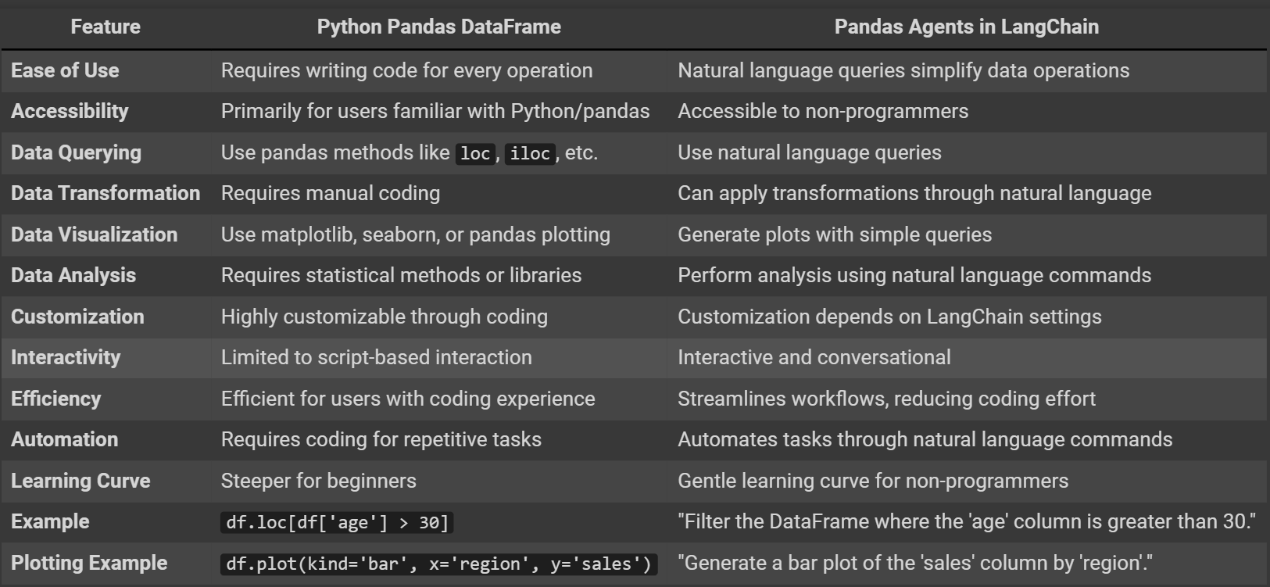**Pandas Dataframe Vs Pandas Agent**

**Applications**

The pandas_agent can be applied in various domains, including:

1. **Financial Data Analysis**: The agent can handle large financial datasets, performing complex calculations and generating detailed reports.
2. **Machine Learning Data Preprocessing**: The agent simplifies the preprocessing of data for machine learning models, handling tasks such as feature engineering, data cleaning, and transformation.
3. **Real-time Data Monitoring and Reporting**: The agent can be used for real-time data monitoring and reporting, providing up-to-date insights and visualizations.

**Conclusion**

The pandas_agent project successfully extends the functionality of Pandas DataFrames, making complex data manipulation tasks easier and more efficient. The agent's advanced features and automated operations improve the overall effectiveness of data analysis workflows. Future work will focus on adding more features, further optimizing performance, and expanding the agent's applications in various domains.

**THANK YOU**